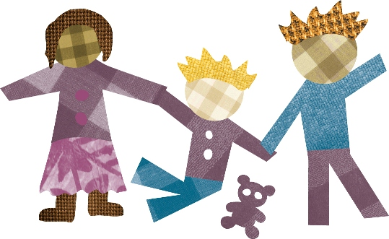
Nga Pukenga Tamariki

Marlborough Children’s Team

Who are we?
Nga Pukenga Tamariki (the Marlborough Children’s Team Panel) works with children and their whanau to support them through challenging times, when just one agencies help is not enough. A support package will be put together to meet the unique needs of individual children and their whanau.

Nga Pukenga Tamariki is a multi-disciplinary team of people from our community, including paediatricians, psychologists, social workers, nurses, and others who work with children and their whanau. We come from different organisations including health, social, education, justice, iwi/Maori sectors, sharing the same key goal as you - working for the best interests of your child.

What can we do for you?
If we think you need our level of support, and we think we can help, we will carefully select one key person to work alongside you (known as the Lead Professional). This person will:

- meet with you and your child, talking about your strengths and needs, and getting a really good understanding of your challenges and concerns
- with your input, begin to put together your support team (a Child Action Network) that will include people you may already be working with, alongside others who bring new skills that together you have decided are necessary
- build a strong plan of actions that will help meet your child’s needs
- make sure that the services your child needs are provided quickly and effectively.
- regularly review with you the progress being made against the plan.

What do you need to do?
You are a key player in the team and can help a lot by:
- providing as much information as possible in your referral form
- meeting regularly with your Lead Professional and openly sharing your concerns
- attending all of the Child Action Network meetings
- actively support the plan as much as you possibly can

Is this voluntary?
Absolutely – and you decide who the members of the Child Action Network will be.

What if my referral isn’t accepted?
We will make suggestions about other possible supports

What if I want to exit from the Marlborough Children’s Team?
You and your whanau can walk away from Nga Pukenga Tamariki at any time

