From home:
- Draw pictures with chalk on your footpath or driveway.
- Get everyone in the family to write a letter to a family member who lives out of town and then post it.
- Make a hut out of sheets and camp in it as a family.
- Read a book together as a family (one person reads a page each)
- Play board games
- Buy a pack of water balloons from the $2 shop, and have a water fight
- Watch movies and eat popcorn
- Fly Kites on the Wither Hills- make your own kite using plastic bags and string
- Cook dinner or bake together as a family
- Picnic or BBQ in the back yard

Out and about- cheap activities:
- Blenheim Bus: around town, get off at Mitre 10 MEGA, play on the playground, have a coffee, and return home on the bus. (Adults $2, children $1, under 5 years and goldcard holders, free).
- Top town Cinema 3: Go and see a movie on cheap Tuesday as a family, all tickets $9.
- Visit the Marlborough Museum, Brayshaw Park, as a family, Open every day 10 - 4. Adults $10, Children and students $5.
- Go for a swim at Stadium 2000. ($5 adults, $3 children or $12 family)
- Day trip to Picton; playground, mini golf, aquarium, ride the train, sail a miniature yacht, walk the waterfront or the trail to Bob’s Bay from the Coat hanger bridge
- Visit the Omaka Aviation Museum ($62-family pass)
- Ten pin bowling, Batty’s Road (Indoor Sports Centre) family $35.
- Lochmara Lodge – nature reserve, hammocks, swing rope, kayaks, bush walk

Fun Stuff
for Families
to do in
Marlborough

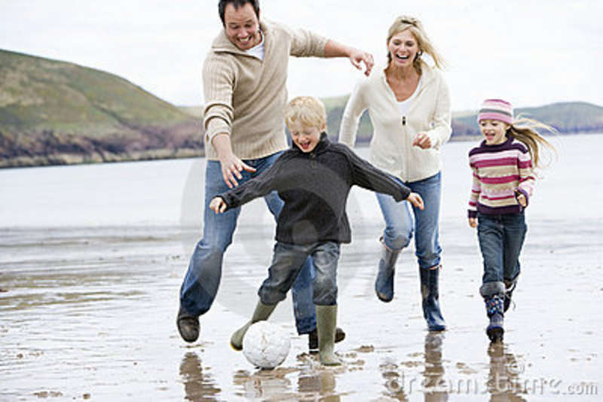

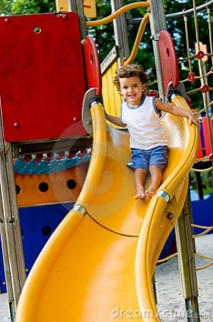
Out and about- Free:
- Oliver Park, Redwoodtown: Bike around the mountain bike track, enjoy having turns on the flying fox, take a cricket bat and tennis ball and play cricket at the cricket net.
- Pollard Park: Complete the fitness circuit, take a picnic, feed the ducks, and play on the playground, take some sausages and have a BBQ
- Walk the Withers and find new trails
- Visit the Marlborough Millenium Art Gallery (opposite Seymour Square) and the Yealands Art Gallery (High Street) and admire the Artwork. Gold coin donation for both galleries.
- Go to the Library and complete a puzzle as a family.
- Go for a walk or a bike ride up the Wither Hills, as a family.
- Take all the bikes, scooters and skateboards down to the skate park
- Walk or Bike along the Taylor River as a family
- Walk the Lagoon and watch all the birdlife as a Family (approx. 3 hour walk, start is at Hardings Rd).
- Go for a swim and pack a picnic at Pelorus Bridge
- See the Seals at Ohau Point
- Visit Roselands petshop and look at the animals.
- Fishing off the wharf in Picton or at the Wairau Bar
- Makana Chocolate shop – tasting and watch the chocolate making
- The Honey Company – live bee display on Taylor Pass Road
- The Vines Village -fudge tasting, area for kids to play and ice creams at the café
- Rarangi Beach- Walk over to Monkey Bay, collect driftwood, brand new playground by the firestation.
- Drive up the Waihopai Valley and go swimming in Craiglochart
- Farmers Market – story time, live music, fresh fruit icecreams
- Pine Valley – walking tracks and adventure playground
- Take a side road to the Wairau River and picnic on the riverbank, paddle in the river shallows
- Whites Bay – lovely sandy beaches, take the Black Jack walk which is an easy loop track
- Molesworth - take a 4wd through high country and stop at historic cob cottage for a picnic.
- Taylor dam- feed the ducks and play on the playground
- Look at all the boats and yachts at the Picton, Waikawa or Havelock Marinas
- Read the Marlborough 4 Fun Event Guide for activities including summer concerts and Christmas events.

